**TASK 3: Modify Instance Type**

1. **Make it from t2.micro to t2.small or t2.nano.**

**Steps to modify Instance Type from t2.micro to t2.small:**

1. Firstly, stop the instance

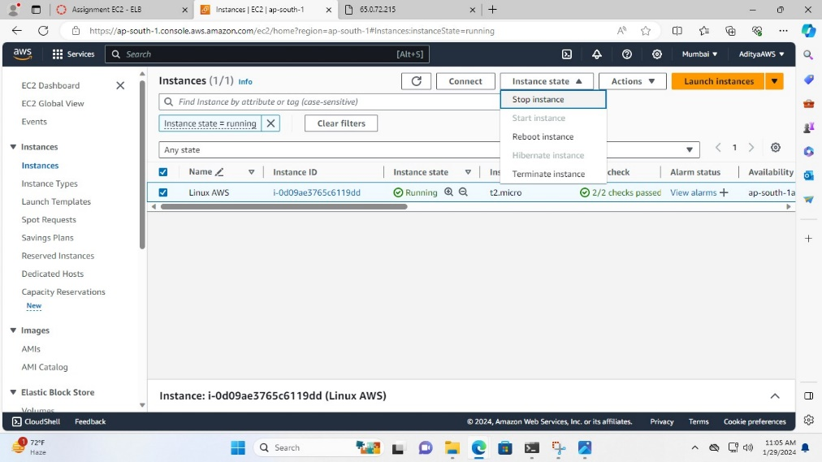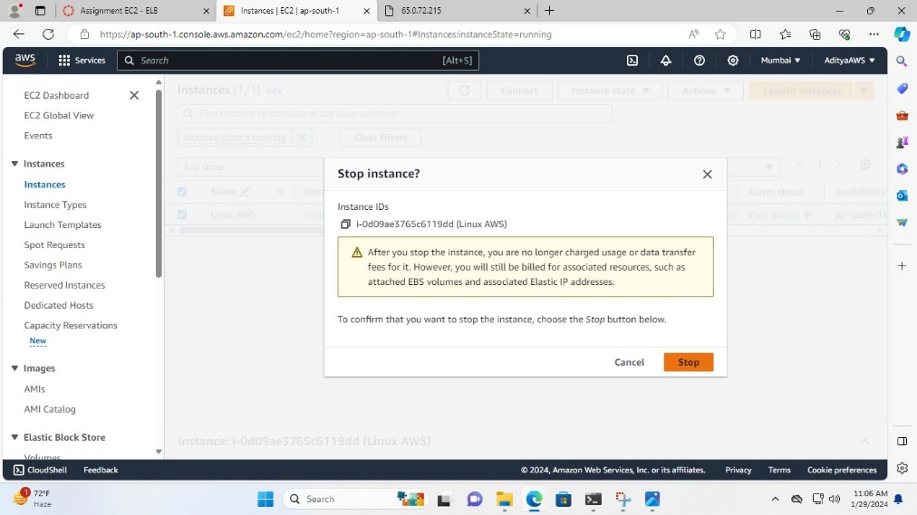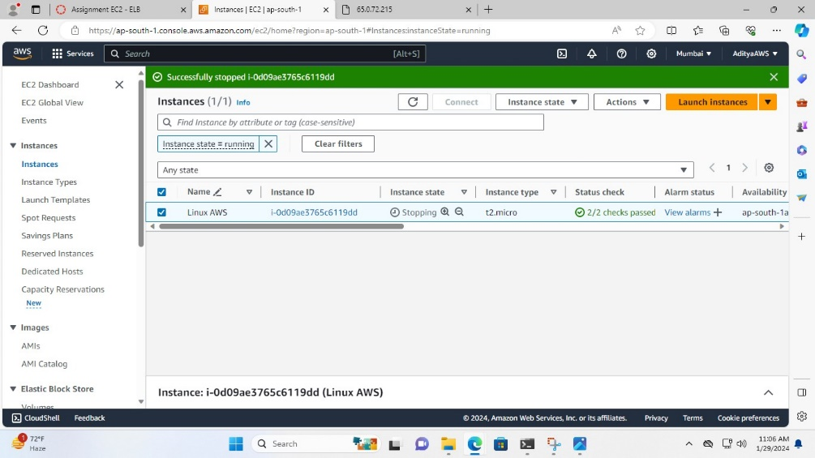

1. Now, go in the Actions drop down in it click on instance settings and in the instance settings drop down click on Change instance type

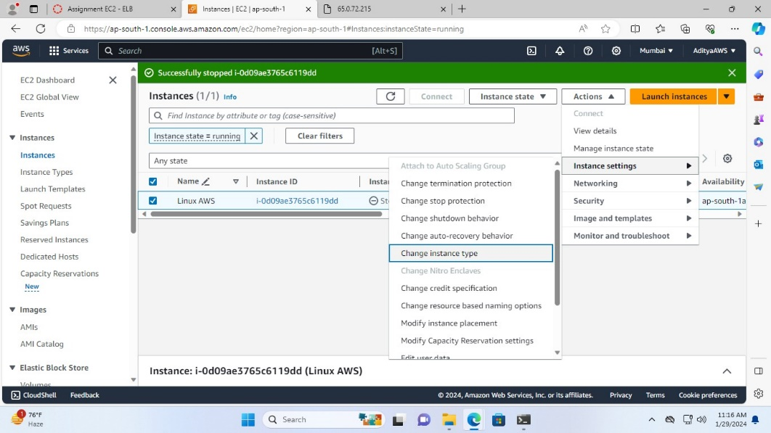

1. In Change instance type tab search for t2.small instance in Current instance type, select it and click on Apply to save the change

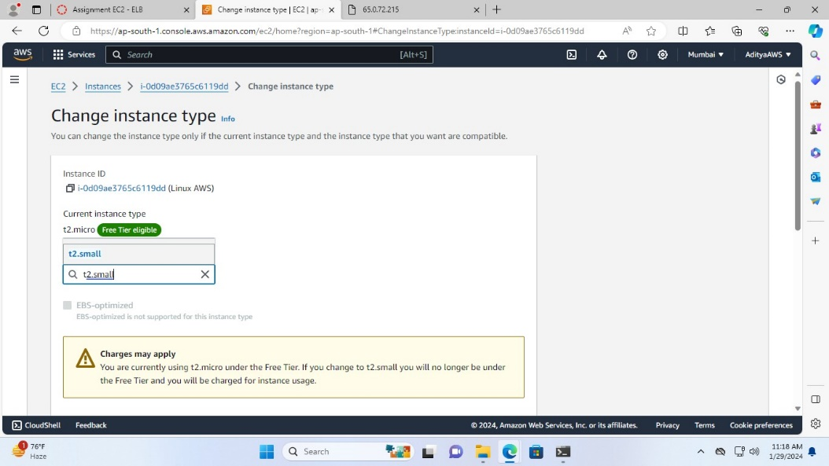

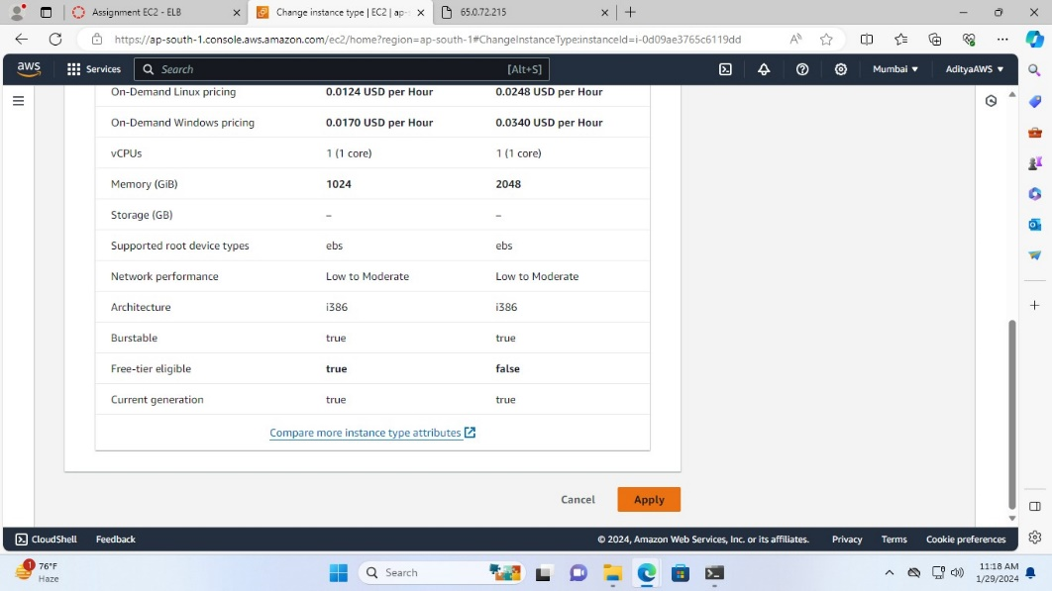

So, the Instance type changed successfully.

